34 Types of Startup Metrics to Measure (with Examples)
Startup metrics and key performance indicators (KPIs) are important to understand and keep track of so your startup can measure, analyze, and grow your business using data, rather than blindly trying to grow.
But not all key performance indicators were created equal. And not all KPIs that are applicable to different types of startups are the right match for your startup. That’s why it’s important to use the right metrics to measure performance.
This post goes over:
- The definition of a key performance indicator
- Startup KPI examples
- A list of 34+ startup metrics with definitions
- KPI goals
  - Finding your startup’s north star metric with examples
  - KPI goal setting
  - Reverse engineering outcomes for startup KPI goals
  - Insight into “S.M.A.R.T. KPIs”
  - Keeping track of and measuring your goals
  - How to avoid getting paralysis by analysis
- Conclusion

Definition of a Key Performance Indicator (KPI)
Just in case you’re brand new to key performance indicators, I’ll give you the definition.
KPIs are certain metrics that you use to measure and determine the performance of outcomes, behaviors, initiatives, and/or activities in your business.

Startup KPI Examples:
- Month over month sales from marketing campaigns (MoMS)
- Email open rates (EOR) or click through rates (CTR) of your email blasts
- Rate of money spent per month (burn rate)
- Conversion rates for lead magnets for visitors becoming email subscribers. (Visitor to lead conversion rate)
- Conversion rates for visitors into free trials and from free trials into paid customers. (Visitor to free trial conversion rate) & (Activation Rate)
- Amount of cash flow coming in and recurring monthly (MRR), quarterly (QRR), annually (ARR), etc.
- Average time spent on your website (average session duration)
- Time spent on a page (time on page)
- Returning visitors to your app or website (returning visitors)
- Daily, weekly, or monthly active users on your app or website (DAU, WAU, and MAU, respectively)
- The rate in which visitors come to your website and leave without any interactions or clicks (bounce rate)
- User satisfaction (net promoter score (NPS))

List of Startup KPIs
There are quite a lot of key performance indicators that can be used to measure startup performance.
Below, you’ll find the more than the 34 types of startup metrics as shown in the infographic and what each KPI means.
1) MRR (Monthly Recurring Revenue) = The amount of revenue you make that recurs monthly
2) ARR (Annual Recurring Revenue) = The amount of revenue you receive that recurs yearly
3) ARPA (Annual Revenue per Account) = MRR / Total # of Customers
4) Gross Profit = Total revenue minus the cost of goods sold
5) TCV (Total Contract Value) = Value of one-time and recurring charges
6) ACV (Annual Contract Value) = The value that a contract will bring to your business annually
7) LTV (Lifetime Value) = Prediction of the net profit from the entire future relationship with a customer
8) Deferred Revenue = Amount that was received by a company in advance of earning it
9) Billings = Current quarterly revenue + deferred revenue from the previous quarter
10) CAC (Customer Acquisition Cost) = How much it costs, on average, to acquire a customer
11) CCR (Customer Concentration Risk) = Revenue from largest customer / total revenue
12) DAU (Daily Active Users) = The number of users that return to your startup’s site or app on a daily basis
13) MAU (Monthly Active Users) = The number of users that return to your startup’s site or app on a monthly basis
14) Number of Logins = The amount of times users have logged in to your portal
15) Activation Rate = Number of users taking a specific action to get value out of a product
16) MoM (Month-on-Month Growth) = The rate of growth from month to month, comparing the the current month or past 30 days to the previous month or last 31 to 60 days.
17) CMGR (Compounded Monthly Growth Rate) = (Latest Month/First Month) ^ (1 / # of Months) – 1
18) MCR (Monthly Churn Rate) = Lost customers this month / prior month total
19) Retention by Cohort = % of original installed base (1st month) that are still transacting
20) GCR (Gross Churn Rate) = MRR lost in a given month / MRR at the beginning of the month
21) Net Churn = (MRR lost – MRR from upsells) this month / MRR at the beginning of the month
22) Monthly Cash Burn Rate = How much money you spend per month (gross)
23) Net Burn Rate = Revenues – gross burn
24) Gross Burn = Monthly expenses + any other cash outlays
25) TAM (Total Addressable Market) = Revenue opportunity available for a product
26) ARR (Annual Run Rate) = Projection of current MRR into the future, annualized
27) Gross Margin = Difference between revenue and cost of goods sold
28) Sell-Through Rate = Number of units sold in a period/number of items at the beginning of the period
29) Network Effects = Effect of one user on the value of that product to other people (example: Metcalfe’s Law)
30) Virality = Viral coefficient = average number of invitations sent existing user * conversion rate of invitation
31) NPS (Net Promoter Score) = How likely user is to recommend your product to a friend
32) Platform Risk = Dependence on a specific platform or channel
33) Direct Traffic = Traffic coming directly to your site via a link or entering the URL
34) Organic Traffic = Unpaid traffic from search results
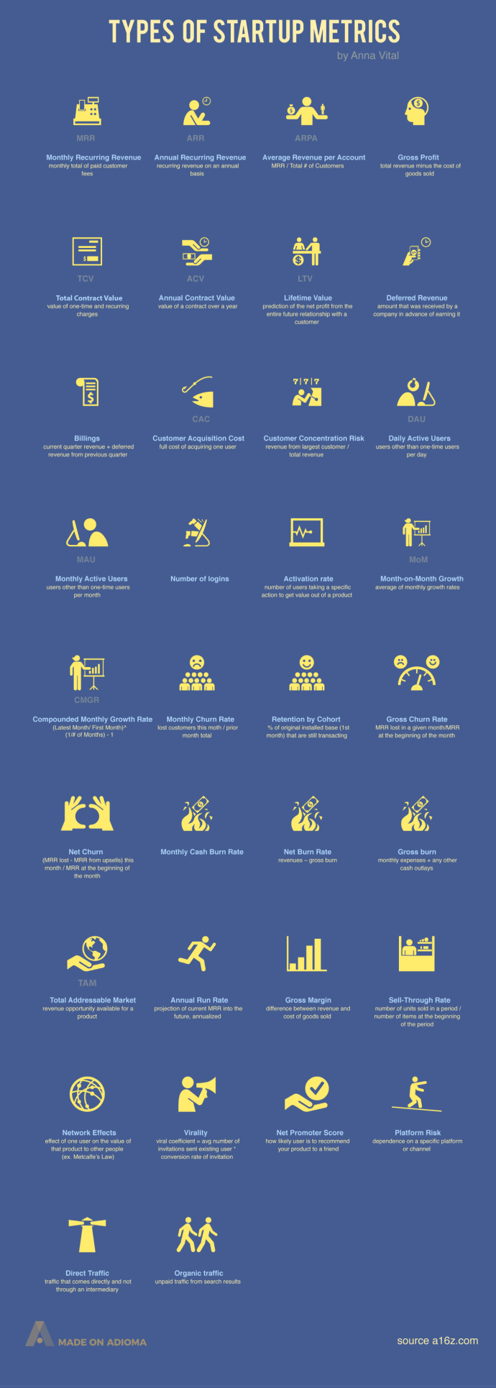

KPI Goals
Before you can measure any marketing campaign or startup website performance metrics, it’s crucial to have numerical goals which are measured with KPIs.
And, when you create goals for your startup, then you’ve got to find your top one or two KPIs.
These top KPIs are called your “North Star(s).”
However, it’s ideal to choose one KPI for your north star over all others.
1) Finding Your North Star(s)
You can find your north star(s) by analyzing what are the most important metrics for your startup.
These north star metrics are the most important metrics for startups to focus on and they allow your startup to formulate a plan which synergistically builds your startup strategy around that north star.
Think about it: what is the ONE main driver of growth for your startup and how can you measure and align your business initiatives around that one driver of growth?
For instance:
Some companies make free trial signups and paid conversions to be their most important metrics and do that because they know they’ll have a higher likelihood of getting a customer that way.
Some startups might have an easy time getting new customers in the door but their largest focus is on customer retention.
Facebook’s #1 north star was daily active users and still is. So their focus is keeping people on the platform and keeping them engaged on it daily.
Which KPIs you use, specifically, are up to you and your startup to decide because they depend on the goals of your website, product, and/or service.

2) KPI Goal Setting

Goal Setting
If a startup sets loose goals, then they’ll achieve mediocre results.
Set specific goals for your each of startup’s your main metrics to have the best results.
Just in case you don’t know how too do that I’ll show you in the following sections.

3) Reverse Engineering Outcomes for Startup KPI Goals
The second habit in the best-selling book The Seven Habits of Highly Effective People by acclaimed self-help author, Stephen Covey, is to “begin with the end in mind.” And this is so true.
I’ve found it’s both helpful and important to set numerical goals with time frames to achieve them by with both startups and in life.
To help you achieve your numerical goal, try reverse engineering your goal from the desired end result divided by the number of days and weeks it will take to reach that goal.
With reverse engineering, we want to get as granular as possible. That’s why you split it up into days and weeks.
It’s also due to the fact that if there’s a loose weekly goal or a monthly goal, then you’ll probably have poor results and won’t be able to correctly reverse engineer your efforts.
Nobody wants that. Below you’ll see the nuts and bolts that allow you to reach those goals.

Aligning Activities Towards Your Goal(s)
Make a list of all of the things that you can do to achieve the outcome you’re looking to get and write all the things you can do to make it happen for the campaign and achieve the highest conversion rate for that one specific north star.
It may be that you’ll be using a mix of the following to :
- Content marketing on social media
- Email marketing
- Push subscription notifications
- Facebook messenger notifications
- Instagram and Facebook live videos
- YouTube videos
- Posting on your social media pages, timelines, and groups
- Talking about it in your community/niche channels and groups
- Paid ads
- Lead flows within your website
- New landing pages for the specific campaign or goal
- Partners promoting with/for you
- Influencer marketing

4) Insight into “S.M.A.R.T. KPIs”
According to Pyramid Analytics, an analytics and business intelligence suite, SMART is an acronym that stands for: Specific, Measurable, Actionable, Relevant, and Timely. And they gave us permission to share their expertise on KPI effectiveness and SMART KPIs through the image below.
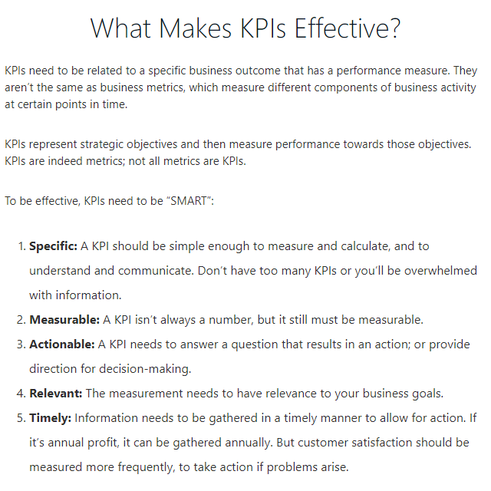
Image captured from PyramidAnalytics.com
Your startup’s north star should be SMART, as should your other most important metrics. When you align your marketing efforts towards increasing north star and KPI effectiveness, you’re going to be able to get measurable results that are very likely to increase your bottom-line (usually revenue).

5) Keeping Track of and Measuring Your Goals
In addition, having a handful of your top key performance indicators tracked in a spreadsheet will help you significantly because you can then have laser-focused attention on what matters most for your startup.
Below is an example of a SaaS spreadsheet metrics dashboard created in Google Sheets by Growth Everywhere.
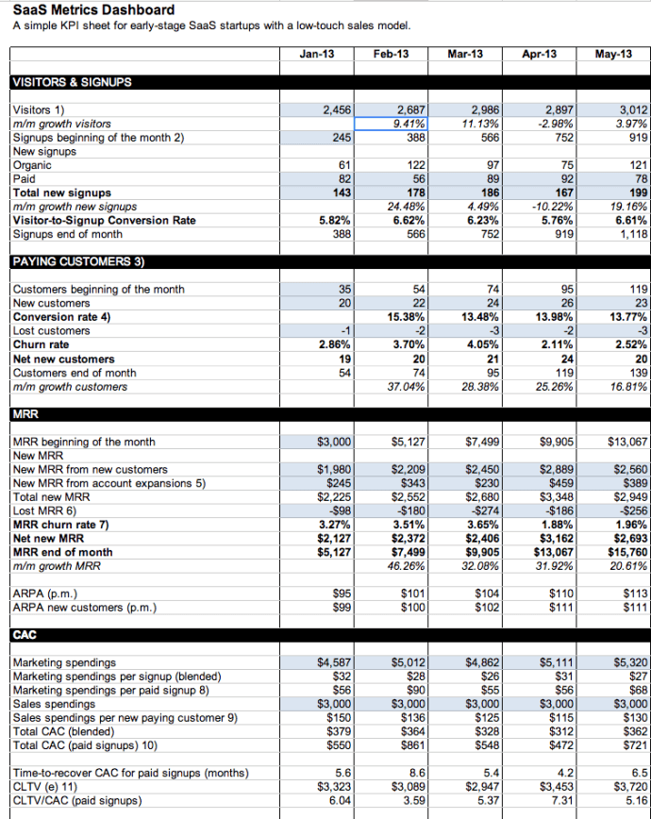

6) Reviewing Analytics Reports Can Be Time-Consuming – How to Avoid Getting Paralysis By Analysis
Bob Parsons, the Founder of GoDaddy, once said: “Anything that is measured and watched, improves.”
I would have to disagree because you don’t want to suffer from paralysis by analysis and keep reading and analyzing and waste your time.
It’s so easy to fall into this trap. I know because it’s happened to me several times haha. Please learn from my mistakes.
To avoid wasting your time from paralysis by analysis, I recommend to schedule specific times to monitor your conversion rates.
I like Fridays because it’s the least active day business-wise and I can schedule the changes I need to make to optimize StartupDevKit for the next week. I will also look towards the end of the business day, depending on what I’m doing.
Conclusion
Key performance indicators are the startup metrics that are going to be your best friends. They are how you measure your startup’s growth and everything in between.
If you’re new to using analytics and you’re learning about key performance indicators, try to not get overwhelmed and have confidence that you can learn it. This is going to be especially important if you’re a first time startup founder because every startup founder needs to be able to understand the data and how it translates into business performance

It can be intimidating to sit down to a blank slate and begin working on your company’s first official KPI KPI Examples for Technology Companies dashboard! Over the years, I’ve worked with hundreds of technology and software companies doing just that - beginning their KPI journey in Rhythm. So how do you get started?
First, it’s helpful to think of your business in terms of 4 key areas: Employees, Customers, Processes and Revenue. In order to have a clear high-level view of the health of your company, you should have visibility on all four areas. What can you measure to give you the proper insights on the health of your employees, customers, processes and revenue?

If you are still stuck, we’ve compiled the ultimate KPI cheat sheet for software companies! Below are some of the most common KPIs we’ve seen from technology companies using Rhythm for each of the 4 key areas:

Employee KPIs
Are your employees engaged, productive, delivering results, and excited about the future?
Employee KPIs
- Employee Net Promoter Score
- Retention of A Players
- Employee Health
- Customer KPIs
Do your customers love, appreciate and refer you?
- Customer KPIs
- Customer Retention/Churn
- Customer Referrals
- Customer Net Promoter Score
- # of Open Customer Support Tickets
Process KPIs
Do you have healthy operations and disciplines that you can scale for the future?
Process KPIs
- Mean Time to Recover (MTTR)
- Ticket Resolution Time
- On-time Delivery
- A/R Days
- Expenses
- Margin
- Profit
Revenue KPIs
Do you have the right product/service offerings and marketing/sales strategies to support your current and future revenue goals?
Revenue KPIs
- New Customer Sales
- Existing Customer Expansion
- Cost of Customer Acquisition
- Close Ratio
- Close Cycle
- Recurring Revenue
- Pipeline
- Cash Runway
Finally, you and your team just need to get started. Start measuring some KPIs that you think will give you the proper insights and drive the right discussions at your Weekly Team Meeting. Test them and don’t be afraid to make adjustments to your software KPI list. If a KPI isn’t giving you good insights or prompting action when you're not on track, stop measuring it and try a different metric. It may take a few quarters to determine your best KPI set. These KPIs also apply to IT (Information Technology) companies and many others, so feel free to download our guide and create the best technology KPIs for your team.
According to a recent article I read in Harvard Business Review, "most employees want to be productive, Productivity KPI Examples to Measure Productivity Metrics but the organization too often gets in their way. Our research indicates that the average company loses more than 20% of its productive capacity — more than a day each week — to what we call 'organizational drag,' the structures and processes that consume valuable time and prevent people from getting things done." What productivity KPIs (Key Performance Indicators) and metrics can we measure employee performance, employee satisfaction and employee engagement?
The article continued to say that "people have huge amounts of discretionary energy that they could devote to their work, but many are not sufficiently inspired to do so. Virtually every employee can bring more to their job, but many don’t invest the additional ingenuity and creativity that they could to improve productivity. Inspired employees bring more discretionary energy to their work every day. As a result, they are 125% more productive than an employee who is merely satisfied. Stated differently, one inspired employee can produce as much as 2.25 satisfied employees."
Wow! I was stunned by this data!
Does your company have a productivity mindset that allows your employees to be inspired by their work? Can I measure their productivity with a set of productivity KPIs that the whole team can easily understand? Do they understand why they are taking this KPI measurement? Do you use KPI dashboards to measure performance over the time period to see improvement? What types of productivity metrics can we use to monitor and inspire our team?

Or is your company suffering from “organizational drag”?
Let’s focus on the KPIs and productivity metrics that you are currently measuring. Do they promote and engage your employees in producing the output you are seeking? What key productivity metrics and KPIs should you be measuring to ensure your company is growing at the pace that you desire?

During your next planning session, you should do a KPI audit as a starting point to evaluate what KPIs are promoting productivity and which are not. Take a look at all of your KPI examples, for the ones that are not promoting productivity, ask yourself why? If you don’t need it, toss it. If you still need it, talk through how you can reframe it to give you the output you desire. You need to measure the performance of the team with the right key performance indicators, as well personal performance KPIs to make sure that you are contributing to the team.
Below are 5 KPI types with examples that your team can consider to produce the productivity you are seeking, some can be measure in real time and others take some time. Make sure to assign your KPIs to the person on your team who will own this number and will be inspired to push for the results you want to achieve your goals.

1) Sales KPIs for Customer Acquisition Measurement
What are the levers your team needs to focus on to close deals, and what are the results you are looking to achieve?
- Deals closed
- Contacts made from networking
- # of calls made
- Trade Shows attended
- # of social media posts
- # of blogs written
- Number of customers
2) Customer Satisfaction Key Performance Indicators
What are the key metrics your service team should focus on to provide and produce the best service experience for your customers?
- Meeting SLAs (service level agreements)
- Customer Satisfaction
- # of client issues resolved
- Call pickup time
- Abandon rate
- Order accuracy
- Rework
- Net Promoter Score
3) Quantitative KPIs to Measure Multifactor Productivity
In manufacturing KPIs, what are the key metrics you need to measure the output of our production line and keep track of the inputs and outputs needed to produce our product?
- Measuring output
- Number of parts produced (Number of conforming products produced)/(labor hours)
- Raw materials
- Downtime
- Overall Equipment Effectiveness
- Reject ratio
- Operating rates (Machines and processes produce goods at variable rates. When speeds differ, slow rates typically result in dropped profits while faster speeds affect quality control. This is why it is important for operating speeds to remain consistent.)
4) Business Operation KPIs Measure Levels of Productivity
What are the key financial metrics that you need to monitor to ensure your business is operating at its best?
- Labor Utilization
- Employee Turnover Rate
- Labor Materials
- Operating Margins
- Training
- Customer Lifetime Value
- Processes and Procedures developed
- Cash Flow
- # of Action List completed/overdue
5) Financial KPIs for the Bottom Line
What key financial numbers do you need to monitor to get a pulse of the business’ financial health?
- Profit
- Gross margin
- EBIDTA
- Quick Ratio
- Revenue/Employee
- Team effectiveness ratio (This measures how much gross profit the company gets for every dollar spent on salary. It's better than measuring profit against time [full-time equivalents] because we want the team to work smarter, not longer)
Remember to make your KPIs worth measuring so that your team doesn't fall victim to organizational drag when planning your KPIs. We hope you enjoyed these production KPI examples. See how Rhythm Systems software can help you execute your KPI strategy and all of your strategic initiatives. If you are looking for more information feel free to download our PDF below, or visit our comprehensive KPI guide.
I know that many of you are also using OKRs, which are similar to KPIs. To learn more about the difference you might be interested in reading OKRs vs KPIs: What’s the Difference? to make sure that you have the right metrics that to help you improve your productivity.
Employee KPIs
1. Employee NPS - Determine your Employee Net Promoter Score (NPS). The Net Promoter Score is a method developed by Fred Reichheld and explained in his book, The Ultimate Question. In a nutshell, it’s based on a direct question and the scoring is on a 0-10 scale. Ask your team if they would recommend a job at your company to a friend or family member. Improve employee NPS and you'll reduce your employee turnover rates and keep your labor costs down.
2. Absenteeism - If not showing up is an issue at your company, engagement is suffering for sure! And not just for the person that called out sick, it also affects other team members that need to cover for their work. This leads to a bad employee experience all the way around and often becomes a self fulfilling cycle.
3. Turnover/Retention - Employees who are not happy will simply leave to find a place where they can be happy. Pay close attention to the tenure of employees who quit. Are you losing A players who have been there a long time?
4. Production/Profitability - Quite simply, if employees aren't engaged, the proof will be in the pudding. If sales are slow or production is down, consider low engagement as a possible cause. Research shows that an engaged workforce is a productive workforce.
5. Employee Health Index - This one is interesting. It's simply a "gut-check" KPI that each employee statuses each week. As an example, I'll share our Red-Yellow-Green success criteria for the Rhythm Consulting team. SuperGreen means "Bring It On" or I have the bandwidth to take more clients or help another consultant. Green is "Balanced" or I feel full but it's just the right amount of work. Red means "I need help" or I don't have the bandwidth to take on additional clients or projects right now. As a team, we discuss our Employee Health Index in our weekly meeting to make sure everyone gets the support they need to remain engaged at work.
6. Glassdoor.com Rating - GlassDoor is a website that allows employees to write reviews of their employers. Reviews are evaluated and companies are rated 1-5 stars. For larger organizations, watching this rating can provide insight not only to how current employees feel, but how those who have left feel. Also, it's great to know what is being said about your organization in the marketplace from a recruiting standpoint.
7. Vacation Days Used - On the surface, the value of this measurement may not seem very insightful; however, a healthy work-life balance promotes employee engagement. Vacation Days Used can also be an indicator of your culture. For example, do people not feel comfortable taking time off? Are they so overloaded a vacation just isn't possible? Do they feel no one has their back if they were to take a few days off? If people aren't using them, there's usually a reason.
8. New Hire 90-Day Failure Rate - Engagement is a mindset. However, employees can become engaged if given the proper tools and training. If new hires are leaving in the first 90 days, they either weren't the right hire from the beginning, or the onboarding process didn't set them up to be engaged. High levels of failure should have you invest more time in the hiring process to make sure that you are getting A-Players.
9. Customer Happiness - This one follows the logic that happy employees equal happy customers. Measure Customer Net Promoter Score. If it's low, consider the possible impact of low employee engagement is having on customer happiness. Low customer engagement is often a sign of low employee engagement. This is a data point that seems to cut both ways.
10. Systems Usage - For those of you using Rhythm software, measure employee engagement with the tool. Are they statusing and commenting on their priorities? Are they collaborating with the team and problem-solving in week meetings? If they aren't excited about the strategy and supportive of the execution of the strategy, they aren't an engaged employee.
Laundry List of KPIs
As the middle market strategy execution experts, we get asked a lot of questions about KPIs or Key 179 KPI Examples for Any Industry Performance Indicators for firms to manage the metrics that matter. In fact, we get hundreds of thousands of yearly views on our KPI blog posts alone! Our comprehensive KPI Guide is one of the most valuable free resources that we offer to the middle market community free of charge to help companies determine the right set of KPIs for their business if they don’t have the resources to utilize our expertise and KPI dashboard software to create a balanced scorecard (BSC) of their performance.
As you’ll see below, we have a wide variety of KPI examples across multiple industries that will help you explore some of the more common KPIs that middle market CEOs and their executive teams use to manage their business. You’ll want to make sure that you provide a good mix of leading indicators (how to create a leading indicator KPI), which hint at future performance and result indicators, which report results already achieved. As they say, what gets measured gets managed so make sure that you choose your KPI examples wisely and build an accountable team to exceed your annual targets. The key metrics, time frame on your KPI report will help you achieve your goals with greater speed through focus and clarity.
The balanced scorecard was created in 1992 by Robert S. Kaplan and David P. Norton as a way to ensure that all of the different attributes of a company's success were accurately measured. We often use this as a lens when looking through company KPI dashboards as we most often find that they are dominated by financial metrics and aren't that balanced at all. A complete KPI scorecard should have performance measurements that include not only financial targets, but also customers and stakeholders, internal processes and employee learning and growth.
As the balanced scorecard institute defines the BSC KPI categories:

Financial: often renamed Stewardship or other more appropriate name in the public sector, this perspective views organizational financial performance and the use of financial resources
Customer/Stakeholder: this perspective views organizational performance from the point of view the customer or other key stakeholders that the organization is designed to serve
Internal Process: views organizational performance through the lenses of the quality and efficiency related to our product or services or other key business processes
Organizational Capacity (originally called Learning and Growth): views organizational performance through the lenses of human capital, infrastructure, technology, culture and other capacities that are key to breakthrough performance
Use these balanced scorecard KPI templates to get your KPI scorecard started. Each of these KPIs measures the performance of a key part of your business to help ensure that you meet the business objectives of the team. Keep in mind that the list is just a starting point; you’ll really need to work with your team to find the ones most valuable for your department to create a balanced scorecard execution rhythm to measure your progress on your company's strategic initiatives for growth. Our extensive list of BSC KPI examples is listed below and also available for download and include customer kpis and scorecard measures for any industry.

financial kpi examples
- Financial Balanced Scorecard KPI Examples (Stewardship)
- Net profit
- Gross profit
- Gross margin
- Net margin
- Profit margin
- EBIDTA
- Quick Ratio
- Revenue per employee (FTE)
- Payroll headcount
- Revenue per customer
- Revenue growth
- Debt to equity ratio
- Team effectiveness
- MRR monthly recurring revenue
- ARR annual recurring revenue
- Cash conversion cycle
- Product revenue
- Service revenue
- Number of days outstanding
- Cash on hand
- ROE return on equity
- Current ratio
- Cash Flow
sales kpi examples key performance indicators
Financial BSC KPI Examples (Sales)
- Deals closed
- Contacts made from networking
- Number of calls made
- Trade shows attended
- Number of social media posts
- Number of blogs written
- Prospects identified
- Sales qualified leads (SQLs)
- Sales accepted leads (SALs)
- Total outbound attempts
- Outgoing Calls
- Emails
- Conversations
- Pain identified
- Number of first appointments set
- Number of second appointments set
- Face to Face Meetings
- Proposals presented
- Proposals pending
- Closed - lost
- Closed – won
- Win rate
- Networking events attended
- Speaking events attended
- Speaking events performed
- White papers published
- RFPs (request for proposals) received
manufacturing and operating industry kpis examples
Internal Process BSC KPI Examples
- Capacity utilization
- On standard operating efficiency
- Overall operating efficiency
- Overall equipment effectiveness
- Machine downtime
- Scheduled downtime
- Unscheduled downtime
- Machine set-up time
- Inventory turns
- Inventory accuracy
- First pass yield
- Failed audits
- Customer returns
- Revenue per employee
- Profit per employee
- Number of parts produced
- Overall equipment effectiveness
- Reject ratio
- Operating rates
- New product SKU sales
- Quality
- Production/output
- Labor cost
- Delivery performance
- Total cost
- Material cost
- Safety
- Reject/scrap
- Equipment utilization
- Total cycle time
- Overtime
- Backlog
- Open orders
- On-time delivery
- Maintain inventory level
- Safety recordables (near-misses)
- Stock-outs
- Daily sales
- Weekly sales
- Monthly sales
- Quarterly sales
- Year to date Sales
- Sales vs. budget
- New revenue from existing customers
- Revenue from new customers
- Training hours
- Internal quality
- DPPM (defective parts per million)
- Number of customer issues
- Labor utilization
- Operating margins
- Training hours
- Customer lifetime value
- Processes and procedures developed
- Quarterly rocks completed
- Week in Sync (WIS) Notes from team meetings week to week - is stuff getting done?
- Number of action list items completed on-time
- Number of action list items overdue
staffing and recruiting HR KPI examples
Organizational Capacity BSC KPI Examples
- Voluntary attrition
- Involuntary turnover
- Number of key hires
- Keep smart (learning)
- Gallup employee engagement survey
- Employee NPS (net promoter score)
- Percentage of “A Players”
- Percentage of “A Managers"
- Number of new hire failures in 90 days
- Number of starts per week
- “Fill percentage” of open jobs
- Percentage of redeployment
- Weekly job orders
- Spread or gross margin
- Applicants to hire ratio
- Employee retention or turnover rate
- Billable hours
- Number of timesheets submitted on time
- Accounts past 60 days receivable
- Submissions per hire
- Temps to full-time hire
- Continuing education and training
- Number of quality meetings per week (sales leading indicator)
- Glassdoor recommendations
- Glassdoor ratings
- Positive social media posts
- Fill rate
- Interview to hire rate
- New hires vs. replacement hires
- Number of billable hours closed/won
- Number of billable hours delivered
- Days to fill
- Revenue
- Client Substitutions
- Hiring manager satisfaction rates
- Job performance (sales quotas, customer satisfaction ratings, etc.)
customer service KPI examples
Internal Customer BSC KPI Examples
- Meeting SLAs (service level agreements)
- Customer satisfaction
- Number of client issues resolved
- Call pickup time
- Abandon rate
- Order accuracy
- Rework
- Average time to resolution
- Average reply time
- Number of support tickets
- First contact resolution rate
- NPS (Net Promoter Score)
- Top agents
- Number of bugs reported
- Customer retention rate
- Support costs as a percentage of revenue
digital marketing KPI examples
Financial Leading Indicator BSC KPI Examples
- Clickthrough rate
- Conversion rate
- Bounce rate
- Email sharing
- Forwarding rate
- Number of email clicks
- Number of likes
- Number of shares
- Number of comments
- Number of new visitors
- Number of return visitors
- Number of downloads
- Number of organic search visitors
- Cost per click
- Average SERP (search engine results pages) ranking
- Number of keywords in SERP top 10
- Number of keywords in SERP top 3
- Percentage of traffic growth over 90 days
- Number of new blog posts
- Number of blog post visits
- Number of impressions
- Customer acquisition
These KPI examples should be enough to get you started on creating your own KPI dashboard to drive your desired business results and performance management. The real secret to creating your KPIs is to pick metrics that are actionable. If you see the number is off there are concrete steps and actions that your team can take to get them back on track. If you are measuring things that you can’t influence, such as the weather, they can’t drive your team to perform the right actions to execute your quarterly plan and hit the goals and objectives set up in your annual planning meeting.
Whenever you set up a new business process or update an existing process, make sure that you track the KPIs to achieve your business goals and objectives. This way you can continually make adjustments at each team meeting to make sure that your processes are driving the key financial metrics that run your business.

t may still feel like the middle of winter to some, but you might find that it is time to do some spring-cleaning when it comes to your KPIs. We recommend tracking no more than 8-12 KPIs at a time for each team, but we’ve noticed that some of our clients get trapped by what we call “KPI creep.” They may start with a list that makes sense for their business, and then over time, the KPIs just get rolled over from one quarter to the next and one year to the next, and they keep adding to the list as they develop new critical numbers or want to move the needle on different metrics. Before too long, their KPI dashboard is like that nightmare closet; you know, like your teenager’s closet, when you open the door and stuff falls out on your head because it is just so full and disorganized. If this is happening to you, you need to perform a KPI Audit to get back to measuring what matters.

I recently came across an article with tips for cleaning out your clothing and making decisions about what to keep, toss and donate, and it seems to me that many of the same tips could apply when conducting a KPI audit.

Step 1: Take everything out of the closet… Everything. When talking about your KPI dashboard, this means that you’re going to take a hard look at every KPI. This will help make sure that you start with a fresh list of only the KPIs you need. Nothing gets to stay in the closet without a hard look. Start your KPI audit with a clean slate, you have zero key performance indicators and are starting from scratch.

Step 2: Don’t put anything back in the closet until you ask yourself some questions:

Does it still fit? If you remember the original purpose of tracking that KPI to begin with, does that still matter to you? Does measuring this metric in this way still make sense for your business?
When’s the last time you actually “wore” it, or used it? If it is still applicable to your business, when is the last time you used this data to make a decision or take some action? What does measuring this KPI cause you to do differently when it is Red or Yellow?
If you came across it now, would you buy it all over again? If you were starting from scratch with your KPI dashboard, would this metric make your short list? If so, why do you care so much about it?
Is it damaged or in need of repair? If it is a KPI that used to work well for you, but doesn’t anymore, when’s the last time you updated the Red-Yellow-Green success criteria? Do you need to refine the way that you measure the KPI to make it work for you again?
If you are stuck deciding whether you should keep, refine, or toss each KPI, use the Infographic below to help you consider each one.
KPI Audit Examples

Step 3: When you have examined each item with the questions above and determined which ones still deserve a spot in your KPI audit closet, hang them back neatly. For your KPIs, this means keeping them organized so that you see what’s most critical to you first. This will help keep your weekly team meeting discussions focused and effective. You aren’t likely to take action on a KPI if it is buried in a list where you have to scroll and scroll to find it. Here are some KPI dashboard organizing tips if you are using Rhythm software:

Decide whether each KPI should be displayed at the company level or in a departmental team. Think about who should own updating the status of this KPI and who should be discussing it each week in their adjustment meetings.
Use Custom Dashboards to create views that are specific to you. If you want to view KPIs from multiple groups together in one place, this is the way to organize them. If you want to be laser focused on only a handful of KPIs to really move the needle on them, put them in a custom dashboard.
While their main purpose is to calculate sums and averages for KPIs that roll up from individuals or departments, Composite KPIs also can be used to group related KPIs together, even if you don’t need them to do any math. This is another way to organize related KPIs in the system so you can keep your dashboards clean.

Step 4: Now that you’ve done the hard work of getting rid of what you don’t need anymore, take an inventory of what’s missing. Do you have any gaps in your new KPI wardrobe? You can use the considerations below to verify that you’re not overlooking an important aspect of your business with your new KPI set:

Think about the six Rockefeller Habits categories for KPIs: Customers, Employees, Shareholders, Make/Buy/Deliver, Sales or Record Keeping (Finance). Are you overlooking one of these areas?
Your KPI list should include a good mix of both leading and lagging indicators. Are you tracking both?
Step 5: Don’t let the clutter creep back in! Keep your KPI closet clean by conducting a mini-audit at every quarter turnover. Every time you start a new quarter, take these steps to help prevent KPI creep:

Make sure you have a compelling reason to continue tracking each KPI on your dashboard rather than just rolling them all over without thinking.
For each KPI you are keeping, ensure that you revisit the Red-Yellow-Green success criteria. You may need to reset your goals for the next 13 week race. This will help keep KPIs relevant for you over time.
When you are adding any new KPIs (such as your critical numbers for the quarter), consider whether there are any you can remove. This will help you keep your list from continuing to grow unchecked.
Keep a schedule for an internal audit of your KPIs at every annual planning meeting and tidy them up at every quarterly planning session.
Step 6: Finally, once you have your beautiful, newly organized set of KPIs, don’t forget to share them! Communicate clearly with your team about your KPI set. It is critical that everyone understands why you are measuring what you’ve decided to measure as well as how it is being measured. For any composite KPIs that go deeper into the organization, standardizing how the data is collected and reported is especially critical. You might need to determine a date/time each week for updates to be made, clarify where the numbers should come from and whether they reflect the current or past week’s data, set a standard for whether numbers can be rounded or abbreviated, etc. This will all ensure that the data you see when you open your KPI closet is accurate.
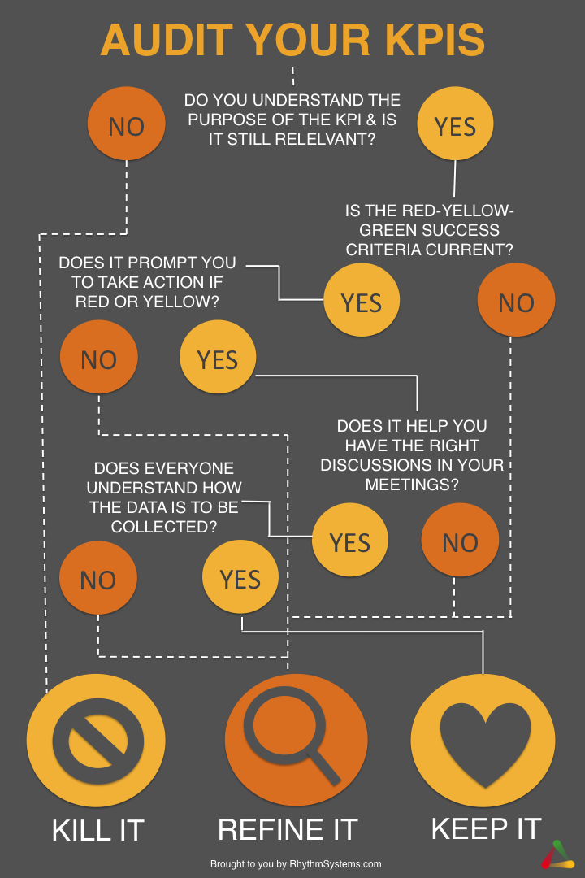
Just like cleaning out your clothing closet, cleaning out your KPI dashboards can be hard work. But, at the end of the day, sitting back and letting the zen of a well-organized and thought-through dashboard wash over you is well worth the effort. Don't forget to do your KPI Audit at each and every annual planning session when you update your annual plan. Remember that all performance measures are not equal. If your performance measures are outdated, it is time to perform a KPI audit and get your KPI dashboards back in order. I hope these audit KPI examples will help you get your team moving in the right direction!

Good luck!

